**IPL Player Auction Dataset Analysis – From Start to Now**

Welcome to the comprehensive documentation of our IPL auction analysis project! Through a meticulous examination of the dataset and employing the power of Tableau, we have curated an array of insightful charts. These visualizations provide team managers with valuable player information, enabling them to make informed decisions during the auctions.

The IPL Player Auction consists of three main perspectives:

1. **Financial Perspective**:

In the financial perspective, our IPL auction analysis focuses on understanding the monetary implications of player selection and team performance. By visualizing key financial metrics like player valuation, auction expenditure, team managers can make data-driven decisions to optimize their budgets, maximize profits, and build financially sustainable squads.

2. **Manager Perspective**:

The customer perspective in our analysis revolves around catering to the fans and enhancing their overall experience. Through visualizations, we explore factors such as player’s origin, his role. By delving into these aspects, team managers can identify potential players, ultimately fostering a more loyal and engaged audience.

3. **Learning and Growth Perspective**:

The learning and growth perspective centers on continuous improvement and talent development. By utilizing Tableau's insights, team managers can assess player performance, track skill development, and analyze key performance indicators over time

**Technical Architecture:**

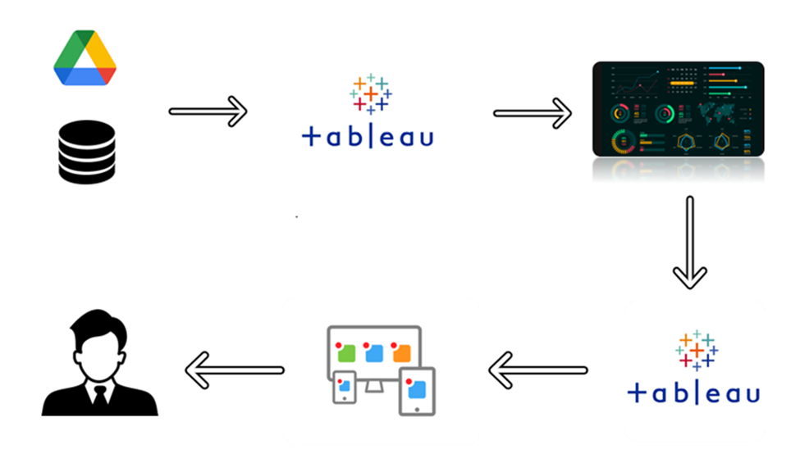

**Project Flow:**

To accomplish this, we have to complete all the activities listed below:

**Define Problem / Problem Understanding**

* Specify the problem
* Business requirements
* Literature Survey

**Data Collection & Extraction from Database**

* Collect the dataset,
* Storing Data in DB
* Perform SQL Operations
* Connect DB with Tableau

**Data Preparation**

* Prepare the Data for Visualization

**Data Visualizations**

* No of Unique Visualizations

**Dashboard**

* Responsive and Design of Dashboard

**Performance Testing**

* Amount of Data Rendered to DB
* Utilization of Data Filters
* No of Calculation Fields
* No of Visualizations/ Graphs

**Project Demonstration & Documentation**

* Record explanation Video for project end to end solution
* Project Documentation-Step by step project development procedure

**Milestone 1: Define Problem / Problem Understanding**

**Activity 1: Specify the business problem**

IPL Auction Analysis Till Now.

**Activity 2: Business requirements**

The IPL auction analysis platform's business requirements include comprehensive player data, auction updates, interactive data visualizations, financial analysis, performance evaluation, user-friendly interface, data security, customizable reports, scalability, integration capabilities, and high performance. By meeting these requirements, the platform aims to empower team managers with valuable insights, aiding in informed decision-making, and ultimately leading to improved team performance and success in the league.

**Activity 3: Literature Survey**

IPL auction analysis project explores existing research and studies related to cricket player auctions, performance analysis, and data visualization techniques. Several studies have investigated various aspects of player valuation and auction strategies in cricket leagues worldwide. Additionally, research on performance analysis methodologies and metrics in sports has provided valuable insights for our project. Furthermore, literature on data visualization tools and best practices has been explored to effectively communicate complex player information to team managers.

Researchers have emphasized the importance of financial perspectives in sports management, highlighting the need for teams to make sound financial decisions during player auctions. Additionally, literature on learning and growth perspectives in sports management has shed light on talent development, skill assessment, and performance improvement strategies. Integrating findings from these sources has contributed to the comprehensive and valuable insights presented through Tableau visualizations in our IPL auction analysis.

**Milestone 2: Data Collection & Extraction from Database**

Data collection is the process of gathering and measuring information on variables of interest, in an established systematic fashion that enables one to answer stated research questions, test hypotheses, and evaluate outcomes and generate insights from the data.

**Activity 1: Collect the dataset**

Downloading the dataset.

**Activity 1.1: Understand the data**

Data contains all the meta information regarding the columns described in the CSV files. We have provided 1 CSV file: IPLPlayerAuctionData.csv

**Column Description for the IPL PLAYER AUCTION DATA**

1. **Player -** It represents the name of the player.
2. **Role -** It represents the role of the player (Batsman, Bowler, All-Rounder).
3. **Amount –** It represents the total amount that the team has paid.
4. **Team-** It represents the name of the IPL Team.
5. **Year-** It represents the year of the Auction.
6. **Player Origin-** It represents the player’s origin whether he is Indian or Overseas.

**Activity 2: Storing Data in DB & Perform SQL Operations**

**Video link:**

<https://drive.google.com/file/d/1oUF6Gq-pea6s7TWKVShMKq2vFYIhjDvP/view?usp=sharing>

**Milestone 3: Data Preparation**

**Activity 1: Prepare the Data for Visualization**

Preparing the data for visualization involves cleaning the data to remove irrelevant or missing data, transforming the data into a format that can be easily visualized, exploring the data to identify patterns and trends, filtering the data to focus on specific subsets of data, preparing the data for visualization software, and ensuring the data is accurate and complete. This process helps to make the data easily understandable and ready for creating visualizations to gain insights into the performance and efficiency.

Colab file :

<https://drive.google.com/file/d/16NT8JS-ITlZkRGjltups7kw_bILIwA_B/view?usp=sharing>

Colab File explanation for the same : <https://drive.google.com/file/d/1HmfsK0glTQBP_0f6kC4MxiuNvkpTIOXk/view?usp=sharing>

**Milestone 4: Data Visualization**

Data visualization is the process of creating graphical representations of data in order to help people understand and explore the information. The goal of data visualization is to make complex data sets more accessible, intuitive, and easier to interpret. By using visual elements such as charts, graphs, and maps, data visualizations can help people quickly identify patterns, trends, and outliers in the data.

**Activity 1: No of Unique Visualizations**

The number of unique visualizations that can be created with a given dataset. Some common types of visualizations that can be used to analyze The IPL Player Auction: including heat map, bar charts, donut charts, pie chart, lollipop chart etc.

**Activity 1.1: Overall Amount Comparison**

**Explanation video link:**

<https://drive.google.com/file/d/1HDqZyrKEfCzrUhpRg1TKsTemRtlFtqyK/view?usp=sharing>

**Activity 1.2: Most Expensive Player each Year**

**Explanation video link:**

<https://drive.google.com/file/d/1EeRCereN-K3xIUIOsVSSlcnMm5D37mGa/view?usp=sharing>

**Activity 1.3: Total Amount spent based on Roles**

**Explanation video link:**

<https://drive.google.com/file/d/18uYu-VMysKgfuJg2k4HWlzBwOxWcEWiF/view?usp=sharing>

**Activity 1.4: Comparison of Amount spent based on Origin of Player**

**Explanation video link:**

<https://drive.google.com/file/d/1Xt8rSBi1F7mdMGq6o1s8ZDJCBhvawyDp/view?usp=sharing>

**Milestone 5: Dashboard**

A dashboard is a graphical user interface (GUI) that displays information and data in an organized, easy-to-read format. Dashboards are often used to provide real-time monitoring and analysis of data, and are typically designed for a specific purpose or use case. Dashboards can be used in a variety of settings, such as business, finance, manufacturing, healthcare, and many other industries. They can be used to track key performance indicators (KPIs), monitor performance metrics, and display data in the form of charts, graphs, and tables.

**Dashboards Explanation Videos.**

<https://drive.google.com/file/d/1HDqZyrKEfCzrUhpRg1TKsTemRtlFtqyK/view?usp=sharing>

<https://drive.google.com/file/d/1EeRCereN-K3xIUIOsVSSlcnMm5D37mGa/view?usp=sharing>

<https://drive.google.com/file/d/18uYu-VMysKgfuJg2k4HWlzBwOxWcEWiF/view?usp=sharing>

<https://drive.google.com/file/d/1Xt8rSBi1F7mdMGq6o1s8ZDJCBhvawyDp/view?usp=sharing>

**Milestone 6: Performance Testing**

**Activity 1: Utilization of Data Filters**

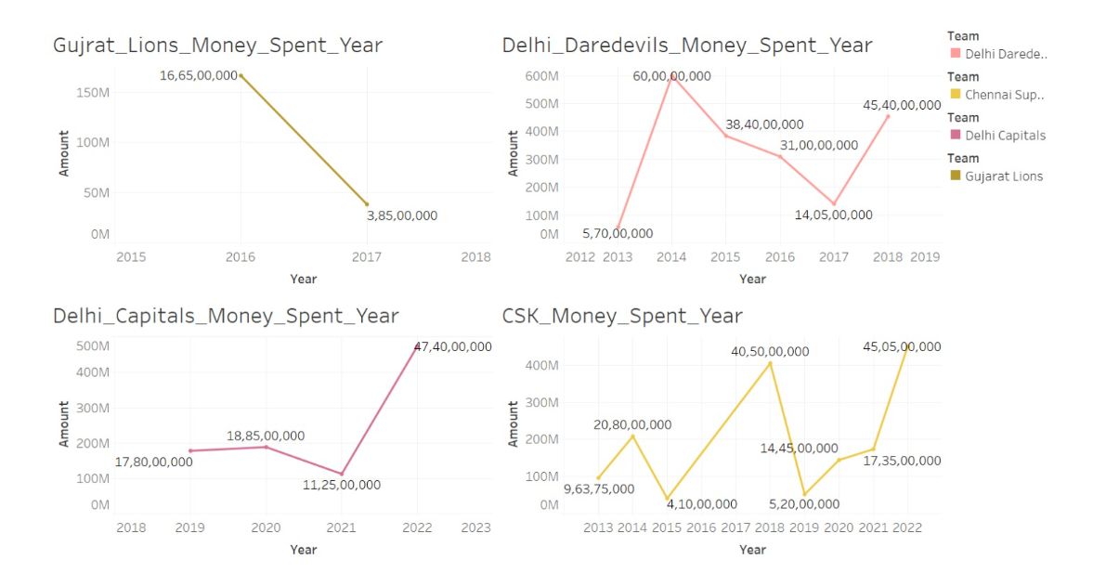

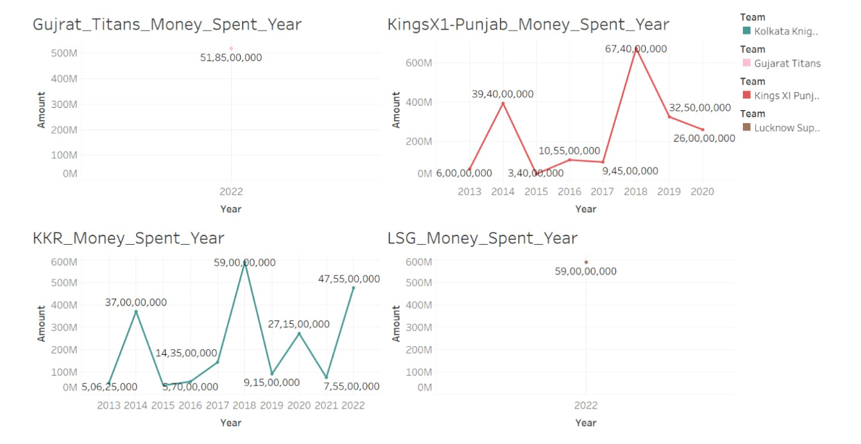

**Activity 2: No of Calculation Fields**

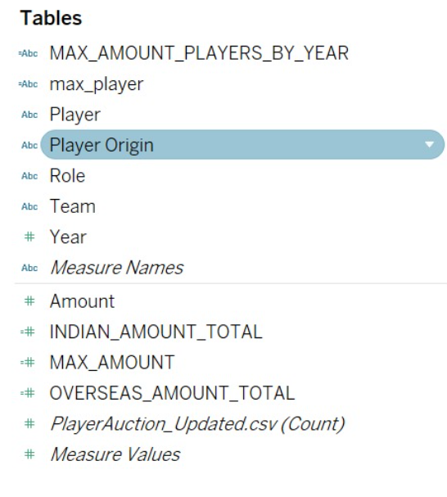

**Activity 3: No of Visualizations/ Graphs**

1. Amount Comparison of each team ( 15 Graphs ).
2. Most Expensive Player each Year. ( 1 Graph ).
3. Total Amount Spent based on Roles. ( 3 Graphs ).
4. Amount Spent by each team each year ( 1 Graph ).
5. Total Amount based on Roles. ( 2 Graphs ).
6. Total Amount spend based on Origin of Player (3 Graphs ).